|  |  |
| --- | --- |
|  |  |

|  |
| --- |
| Linear Gauge by MAQ SoftwareFeatures Document |
|  |

# Short Description

# Linear Gauge by MAQ Software compares your progress against identified goals and warning zones.

# Overview

Linear Gauge by MAQ Software shows progress toward a target value, such as achieved sales versus targeted monthly sales. This visual allows users to include multiple data points, which is useful for illustrating trends such as monthly or year-to-date (YTD) completion rates. Information displayed includes the present value, percentage toward completion, and two optional trend values.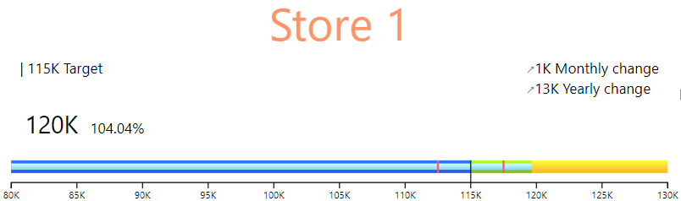

Features of Linear Gauge by MAQ Software:

* Set the minimum and maximum value of the metric.
* Customize the color of the gauge and data labels.
* Choose from six unit options for the metric.

Elements of Linear Gauge by MAQ Software:

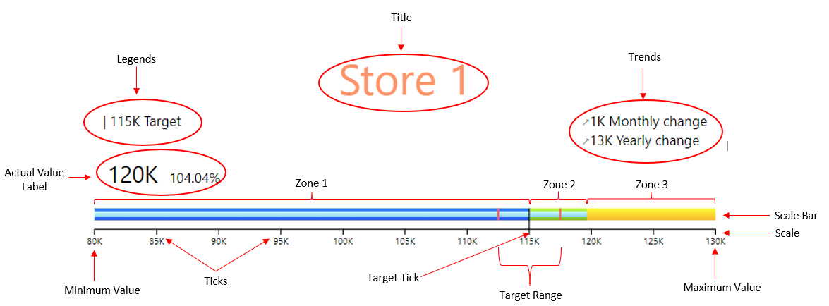

* **Scale**:

View the value ranges. The scale can also be used for placement of the child element, such as the target tick mark.

* **Ticks**:

Specify value intervals along the entire length of the scale bar.

* **Scale bar**:

Display the current progress based on actual, minimum, maximum, and target values.

* **Legends**:

Display the Target Value

* **Zones**:

Specify different ranges between values along the scale bar.

* **Trends**:

Show the general tendency of data points to move in a certain direction over time.

* **Target Range**:

The specified range that we would like to set as our goal.

At a glance, this visual provides a complete picture of your statistical data with a comparison between your actual values & goals.

# Example

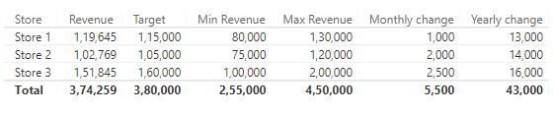

The owner of Store 2 (as seen above) would like to analyze progress of revenue generated by his store.

To begin, they would enter ‘Revenue’ in the ‘Actual value’ field, followed by ‘Target’ in the ‘Target value’ field, ‘Min Revenue’ in the ‘Minimum value’ field, and ‘Max Revenue’ in the ‘Maximum value’ field. The gauge will then show a comparison between revenue generated and the target goal.

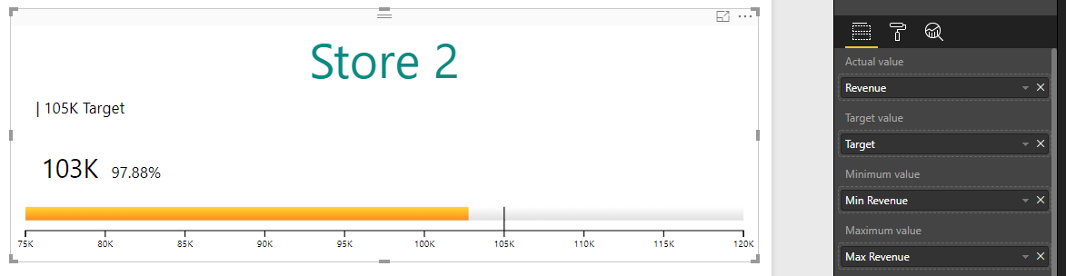

If the owner wishes to identify trends, they can simply enter ‘Monthly change’ and ‘Yearly change’ in the two Trend value fields.

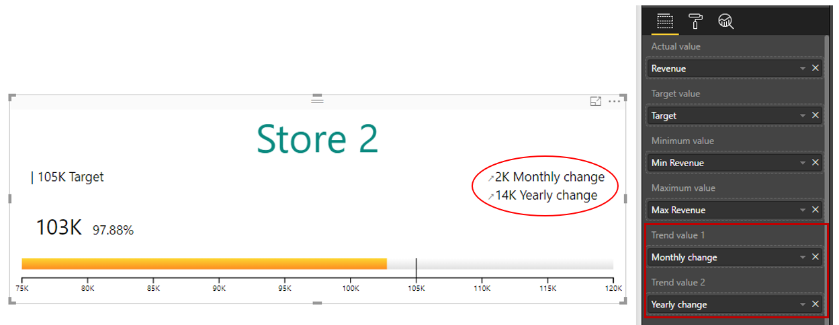

# Configuration Options

* **Change Orientation**

View the Linear Gauge in horizontal or vertical orientation.

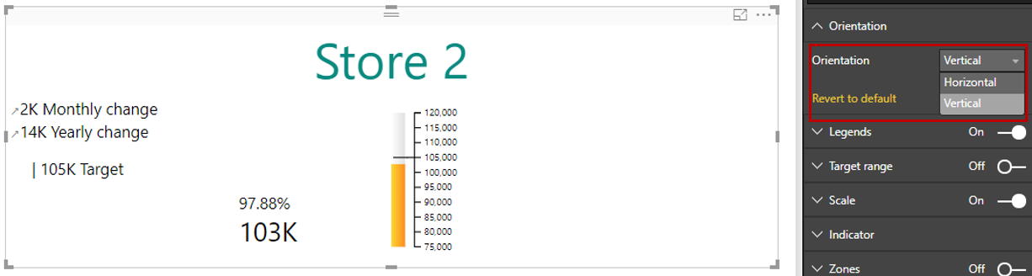

* **Format Legend**

Change color, font size, font family, display units, and decimal places for the Legend.

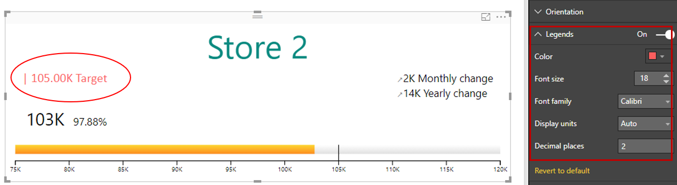

* **Add Target Range**

Include tick marks that identify the target range.

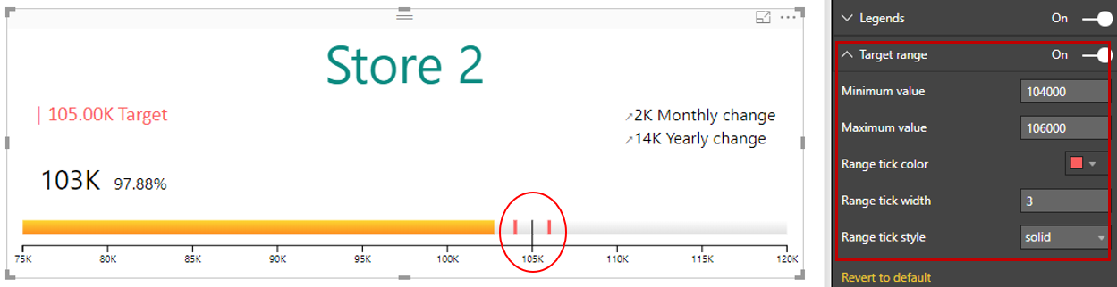

* **Format Scale**

Change color, font size, font family, display units, and decimal places for the scale.

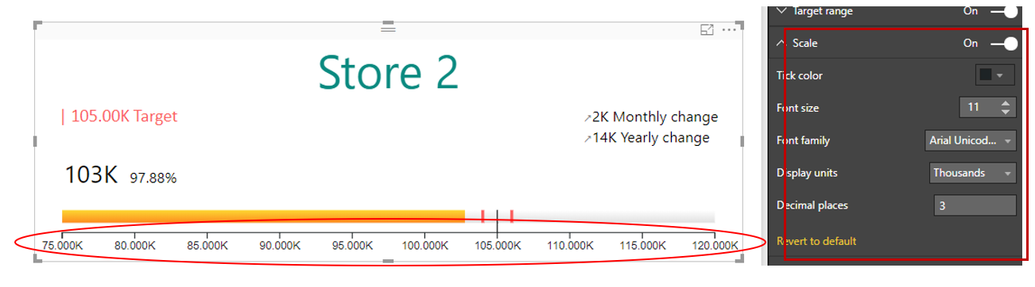

* Add Zones

Mark certain ranges as zones, identified by unique colors on the scale bar.

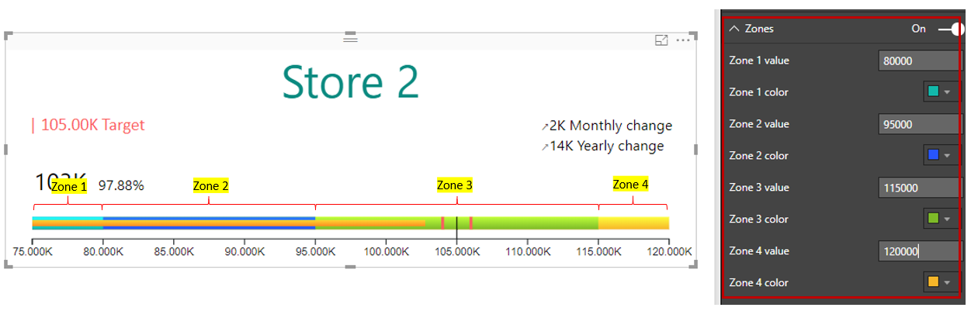

* **Change Scale Bar color**

Create automated color variations for the scale bar, if the ‘actual value’ is less or more than the ‘Target value’.

